Hotel System
Requerements:
Only Computer and windows operation system with .Net Framwork 3.5
Consist of:
6 forms
7 stored procedure
DataSet
This program is compination between Connected and Disconnected mode.

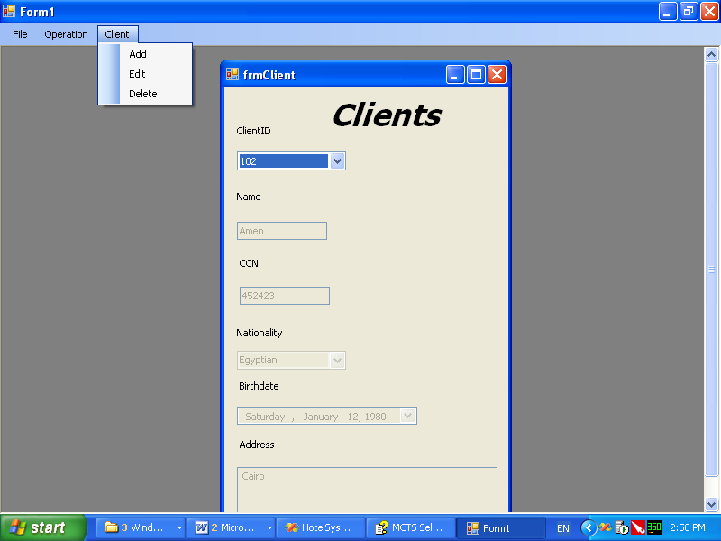
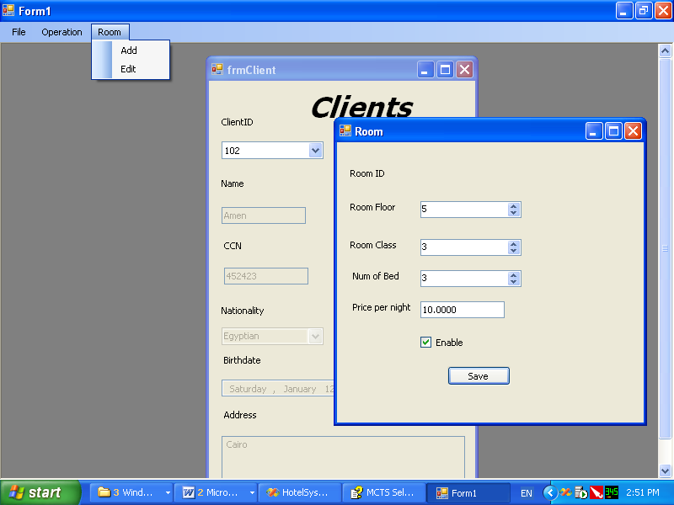
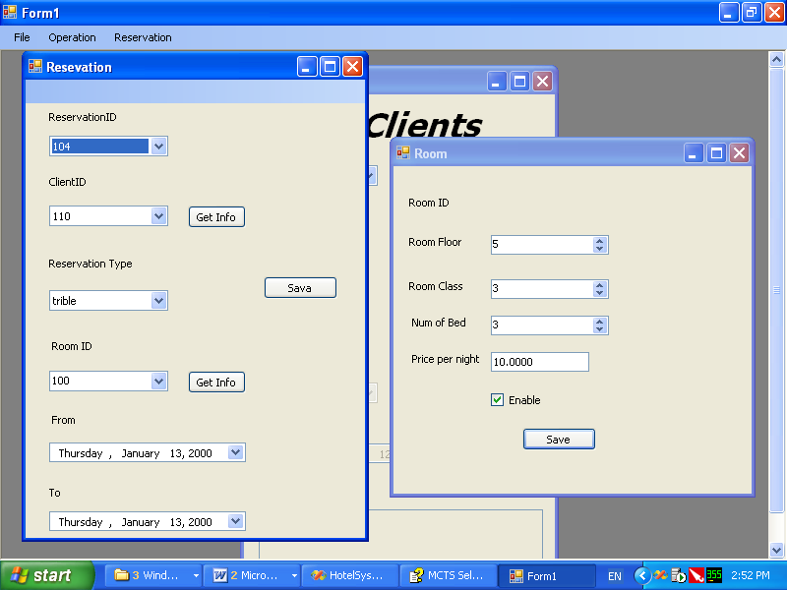
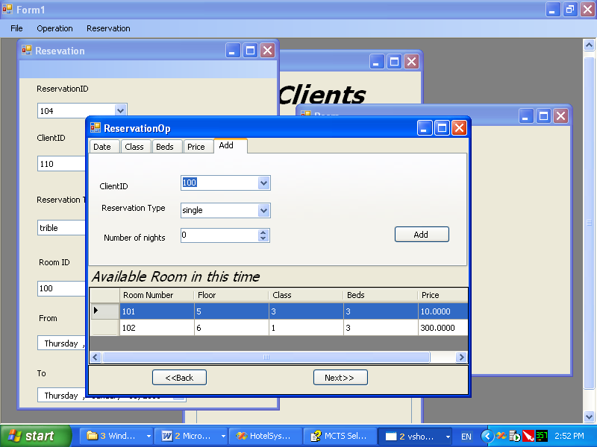
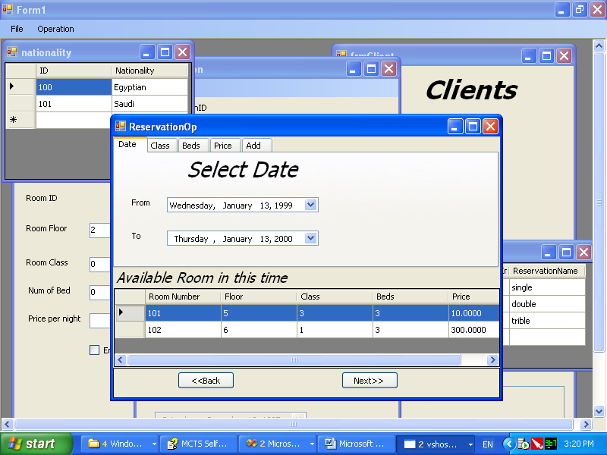
Mohamed Ahmed Rashed
0145624477

